Ideation Phase
Define the Problem Statements

Date | 10 September 2026
Team ID | SWUID2026190374
Project Name | ServiceNow-Based Employee Laptop Request Application
Maximum Marks | 2 Marks

Customer Problem Statement Template:
Create a problem statement to understand your customer's point of view. The Customer Problem Statement template helps you focus on what matters to create experiences people will love.
A well-articulated customer problem statement allows you and your team to find the ideal solution for the challenges your customers face. Throughout the process, you’ll also be able to empathize with your customers, which helps you better understand how they perceive your product or service.

Reference: https://miro.com/templates/customer-problem-statement/
Project-Specific Problem Statements:
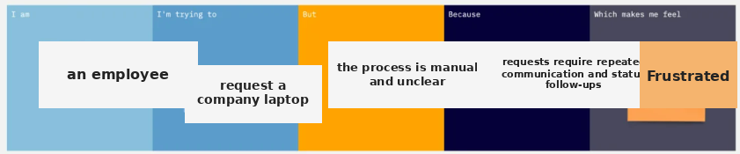

Problem Statement (PS) | I am (Customer) | I’m trying to | But | Because | Which makes me feel
PS-1 | an employee | request a company laptop | the process is manual and unclear | requests require repeated communication and status follow-ups | frustrated and uncertain
PS-2 | an IT support team | fulfill approved laptop requests | information and asset validation are inconsistent | manual handoffs and limited status visibility | delayed and overloaded

